Presentation Title

Stage Setup (Please identify your preference below. Stage setup is limited due to event production capabilities.)

 | Description | Preference
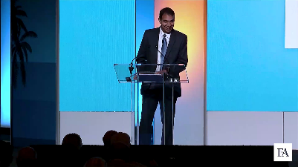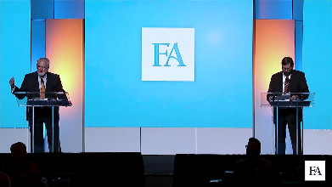 | Podium (1 or 2)  Great for 1 or 2 presenters
 | Couch (1)  Chairs (1 or 2)  Podium (1 or 2)  Great for 2 or more presenters who want to have a conversation. Ideal for panels, discussions, or interviews.
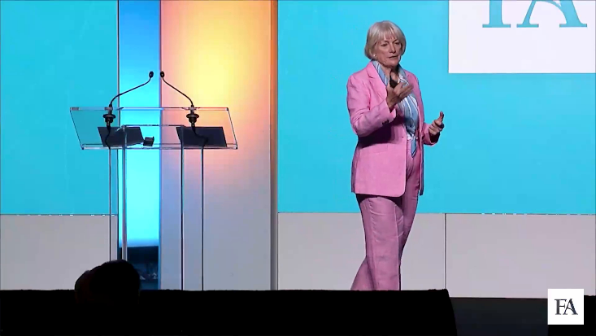 | Freely Walking the Stage  Ideal for 1 presenter who is comfortable with their material and wants to add energy to the presentation while addressing the attendees.

Stage Setup Notes:

Walk-in (Intro) Music (Please include at least 3)
 | Song Title | Artist | Album Title
01
02
03

