New Rules for Closing Residential Transactions
If a buyer of a residential listing applies for a mortgage loan on or after October 3rd, 2015, new federal regulations will apply to the loan transaction. Generally, these new regulations will apply to all transactions involving a new residential mortgage loan. Cash and commercial transactions, even if a residence is involved, are not affected.

New Forms Replace GFE and HUD-1 Settlement Statement
After October 3rd, 2015 buyers applying for a mortgage loan will receive a Loan Estimate from the lender instead of the current Good Faith Estimate (GFE). Buyers will generally receive the Loan Estimate three days after applying for their loan.
The other new form, the Closing Disclosure, will include all of the information currently found on the HUD-1 settlement statement (HUD-1); it will also include an additional three pages of financial disclosures currently found on other forms. The traditional HUD-1 information will be found on pages two and three of the new five-page Closing Disclosure. However, the Closing Disclosure does not use the same familiar categories found on the HUD-1 and some costs are in a different area. For example, your real estate commission and any related charges for your services will be located in Section H labeled “Other” at the bottom of page two of the new form.
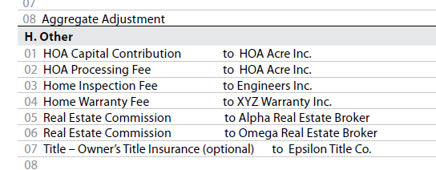
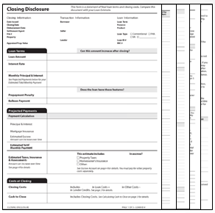

Lender Will Prepare Closing Disclosure
While the new rule allows a lender to authorize a settlement agent to prepare the new form, for a variety of reasons you should expect that the lender will prepare this new five-page form. This is a brand-new challenge for lenders because most of the information currently found on the HUD-1 is gathered by the settlement agent. For example, your commission, association assessments, home warranties, inspection fees, etc.
Settlement agents will continue to be responsible for gathering this information and providing it to the lender. They will need to provide exact information about services and charges to the lender in a timely fashion. Therefore, you will need to communicate your information to the settlement agent much, much earlier than day of closing, perhaps two weeks before the scheduled closing date! Why? Read on.

Borrower to Receive Closing Disclosure 3 Business Days before Closing
The Closing Disclosure must be received by the borrower three business days before closing. (“Business day” here means every day except Sundays and federal legal holidays.) Since it is difficult to determine if a borrower actually received the new form, most lenders will rely on the additional three business days required when the form is mailed, couriered or emailed. That means six business days must elapse from the time the Closing Disclosure is sent to the borrower and closing.
Lenders are routinely announcing that they will require the settlement agent to provide final information to them 10 days in advance of a requested closing date. We believe a good rule for you to keep in mind is “two weeks in advance.”

Revised Closing Disclosure on Day of Closing
The lender’s closing package will be delivered to the settlement agent on the day of closing and it will contain another Closing Disclosure. If no changes have been made it will be the same one sent to the borrower six days in advance. If the information on that form has become inaccurate, or if new information has been added, the package will contain a Revised Closing Disclosure. Usually, this revision will not require another three-day waiting period. Do not rely upon this feature to delay the delivery of information because only the lender can make the changes. Alert your settlement agent immediately to anything that comes up, particularly during the walk-through, so the settlement agent will have time to inform the lender of needed revisions.

Technology and the New Business Model
For a variety of reasons, lenders will be requiring a new method of communication between themselves, settlement agents, borrowers, and others. Phone calls, email, text messages, and faxes may not be acceptable once the transition is complete. This transition is not required to be done by any set date, but lenders have already begun its implementation.
The new method of communication is the electronic transfer of information via a secure internet website. Log-in will be required and all documents and information will be delivered to a lender in this fashion. This internet site will create and deliver the Closing Disclosure using the collaborative efforts of the lender, the settlement agent, and others. Currently, several of the larger residential lenders have identified Closing Insight™, a product of RealEC® Technologies, as the software they will use.

